Contents

SharePoint 2013: Programmatically create a map view with the geolocation field type 2

Description of the sample 3

Prerequisites 3

Key components of the sample 3

Configure the sample 3

Run and test the sample 3

Troubleshooting 3

Change log 4

Related content 4

# SharePoint 2013: Programmatically create a map view with the geolocation field type

This documentation is preliminary and is subject to change.

Summary:   By using the new Geolocation field type, you can integrate location information and maps in a SharePoint list and create location-based map views.

SharePoint 2013 Preview introduces a new field type named Geolocation that enables you to annotate SharePoint lists with location information. For example, you can now make lists "location-aware" and display latitude and longitude coordinates through Bing Maps. An entry is typically seen as a pushpin on a map view. Together, the Geolocation field and the Map View enable you to give spatial context to any information by integrating data from SharePoint into a mapping experience, and let your users engage in new ways in your web and mobile apps and solutions, as shown in Figure 1.

Figure 1. A map view with different pushpin colors

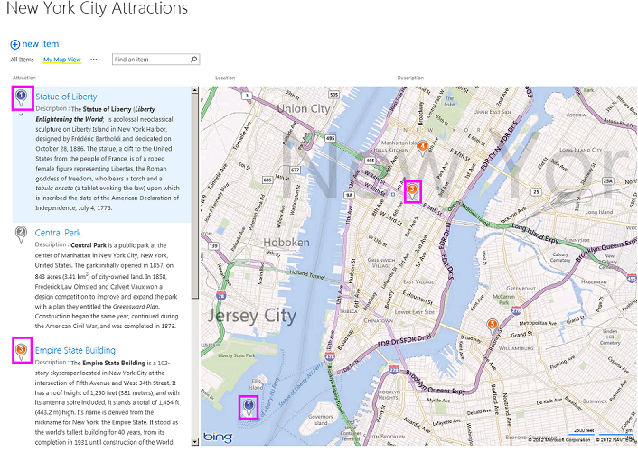

## Description of the sample

This sample demonstrates how to programmatically create a map view to a SharePoint 2013 Preview list. SharePoint 2013 Preview list displays the location on a map powered by Bing Maps. In addition, a new view named Map View displays the list items as pushpins on Bing Maps, a Silverlight control with the list items as cards on the left pane.

This sample is a console application that programmatically creates a map view of a SharePoint list.

## Prerequisites

This sample requires the following:

* Visual Studio 2012
* An installation of SharePoint 2013 Preview, with administrative privileges
* A valid Bing Maps key added at the farm or web level.
* A SharePoint list, with a Geolocation field type column added

## Key components of the sample

The CreateMapView code sample contains the Program.cs file. Program.cs contains the logic of the console application, which creates a map view of the SharePoint 2013 Preview list with the Geolocation field type. For more information about the new Geolocation field type, see **Integrating location and map functionality in SharePoint 2013**

## Configure the sample

To configure the sample, make the following changes to Program.cs.

1. Replace the placeholder "<Site Url>" with the URL of your SharePoint server.
2. Update the placeholder "<List Title>" with the name of the list where you want to create a map view.

## Run and test the sample

* Choose the F5 key to build and deploy the console application.

## Troubleshooting

The following table lists one common configuration and environment error that might prevent the sample from running or deploying properly and how to solve it.

| Problem | Solution |
| --- | --- |
| Error message appears when you open a map view page. | Add a Geolocation column to the list where you want to create a map view. To learn more how to add a Geolocation column to the SharePoint list, see **How to: Add a Geolocation column to a list programmatically in SharePoint 2013**. |

## Change log

| Version | Date |
| --- | --- |
| First version | September 10, 2012 |

## Related content

* **Create a map view for the Geolocation field in SharePoint 2013**
* **How to: Add a Geolocation column to a list programmatically in SharePoint 2013**
* **How to: Set the Bing Maps key at the web and farm level in SharePoint 2013**
* **How to: Create a custom Geolocation field that renders using Nokia Maps**